Phase 3: Execution and End-to-End Testing

1. Phase Overview
The primary objective of Phase 3 is to execute and validate the complete end-to-end lifecycle of the Car Rental Request Automation application. This phase covers portal request submission, manager approval processing, automated catalog task (SCTASK) creation via Flow Designer, and full record lifecycle closure within the ServiceNow platform.

2. Configuration Details

A. Test Execution Metadata
- Test Environment: Development Instance (PDI)
- Target Catalog Item: Car Rental Request
- Test User (Requestor): System Administrator / Logged-in User
- Test Approver: Abraham Lincoln
- Generated Primary Records:
  - Request (REQ) Number: Generated upon portal checkout.
  - Requested Item (RITM) Number: Tracks the car rental request workflow.
  - Catalog Task (SCTASK) Number: Created automatically for fulfillment.

B. Lifecycle Stage & Verification Specifications
Test Step # | Action / Phase | Execution Details | Expected Result / Status
1 | Portal Submission | Navigated to /sp, filled all 7 form variables, and clicked Order Now. | Order Summary generated with REQ and RITM numbers.
2 | RITM Inspection | Opened the generated RITM in the backend list view. | Form variables populated correctly; Approval state set to Requested / Not Yet Requested.
3 | Approval Processing | Added/selected manager (Abraham Lincoln) under Approvers related list and updated state to Approved. | Approval record updated; triggers Flow Designer action.
4 | SCTASK Generation | Checked Catalog Tasks related list at the bottom of the RITM form. | Flow Designer automatically generated SCTASK for fleet team.
5 | Fulfillment & Closure | Opened SCTASK, updated state to Closed Complete. | Overall RITM state updated to Closed Complete.

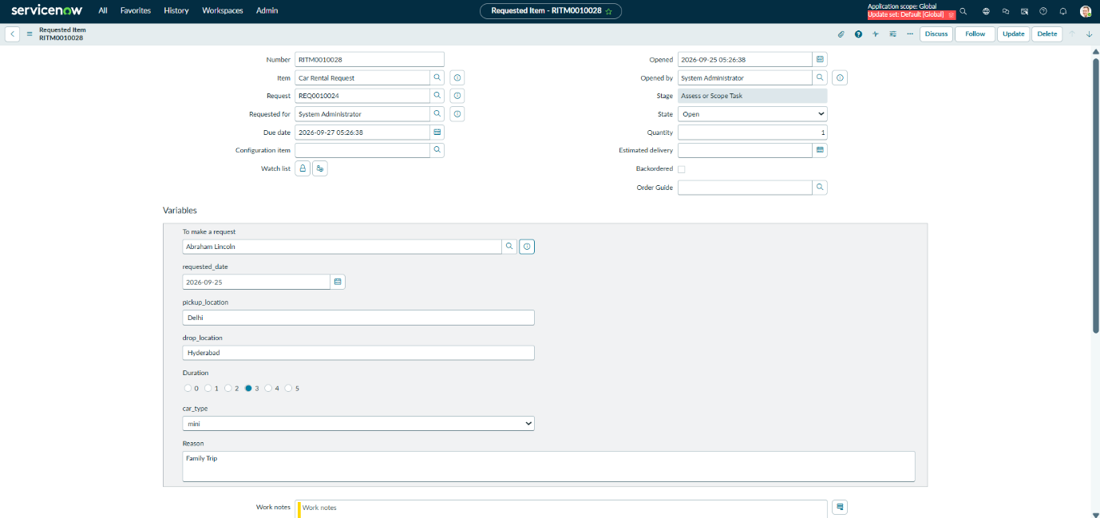

Figure 3.1: Generated Requested Item (RITM) Record with Variable Summary

3. Execution & Verification Steps
- Request Submission via Portal:
  - Opened the Service Portal (/sp) and searched for "Car Rental Request".
  - Entered test details for pickup location, drop location, dates, duration, car type, and reason, then placed the order.
- RITM & Approval Validation:
  - Located the generated RITM record in backend view.
  - Verified that all catalog variables were properly captured under the Variables section.
  - Processed manager approval by setting approval state to Approved.

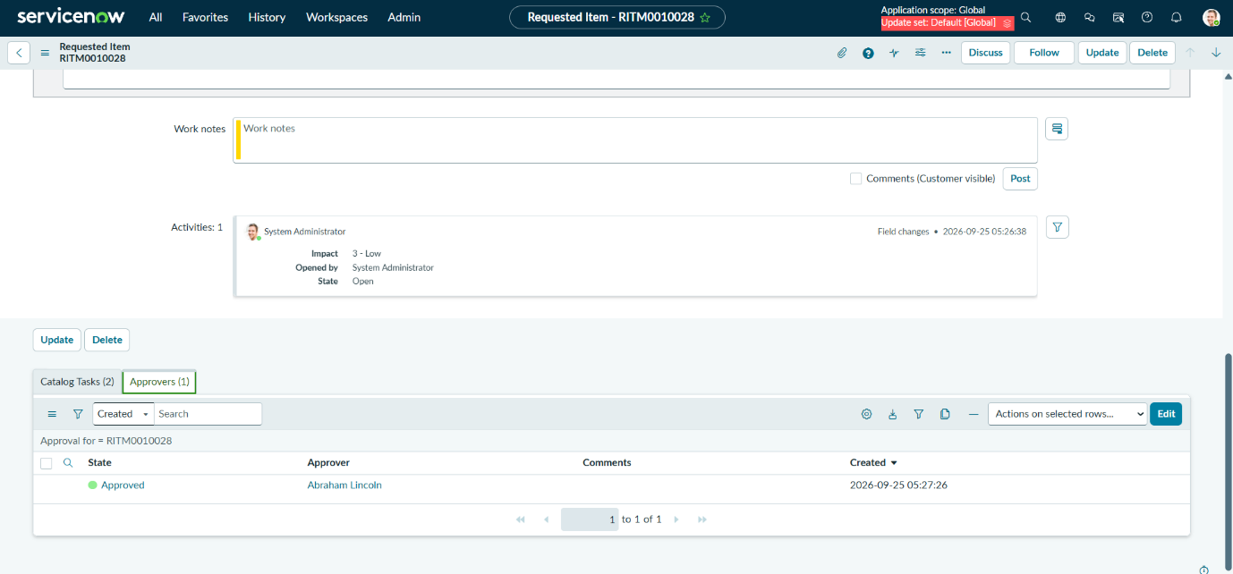

Figure 3.2: RITM Approval state updated to Approved

- Flow Execution & Task Completion:
  - Confirmed that Flow Designer automatically triggered upon approval and generated the SCTASK record.
  - Completed fulfillment steps on the SCTASK and closed the task to verify overall workflow completion.

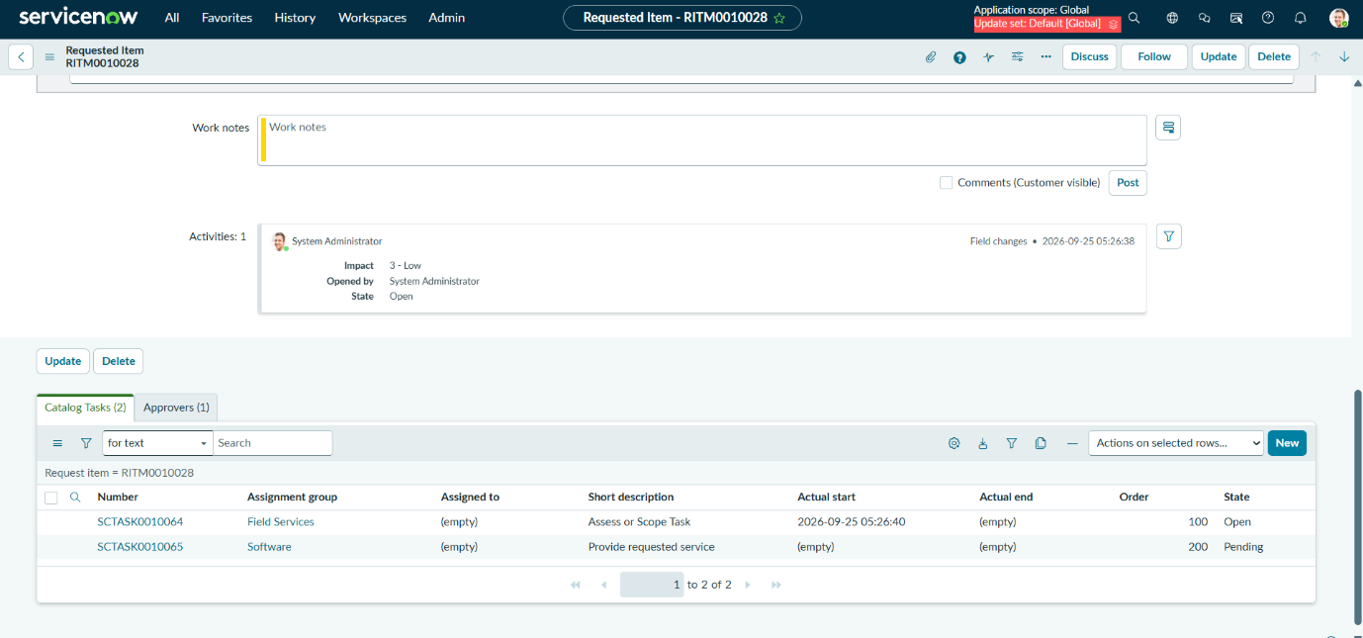

Figure 3.3: Flow Designer Auto-generated Catalog Task (SCTASK) in Related List

